

Student Name: NELIUS NYAMBURA CHEGE

Admission Number: BSCCS/2024/57518

Course: COMPUTER SCIENCE

Unit Code: BIT 4139

Unit Name: ETHICAL HACKING AND COUNTERMEASURES

Lecturer Name: NYORO MICHAEL

Semester: MAY/AUG 2026

TABLE OF CONTENTS
Table of Contents
1
TABLE OF CONTENTS 2
WEEK1: Lab Setup Verification 3
1.1: Verify kali Linux is Ready 3
1.2:Test Connection Between Kali and Metasploitable 3
WEEK2: Penetration Testing 4
2.1: First basic Scan 4
WEEK 3: FOOTPRINTING 6
3.1 DNS FOOTPRINTING 6
3.2 SOCIAL ENGINEERING FOOTPRINTING 6
WEEK 4: Scanning networks 7
4.1 Network Scanning 7
Scanning for live hosts on my network 7
4.2 Port scanning 8
WEEK 5: INFORMATION GATHERING 10
5.1 Domain Registrar 10
5.1.1 IP Address 10
5.1.2 Email Patterns Used 11
5.2 Technologies Running On the Website 11
5.3 Scanning And Enumeration 12
5.3.1 Scanning Ports 12
5.3.2 Detect Running Services 12
5.3.3 Identifying The OS Version 12
5.3.4 Enumerate Shared folders 13

WEEK1: Lab Setup Verification

Step 1.1: Verify kali Linux is Ready

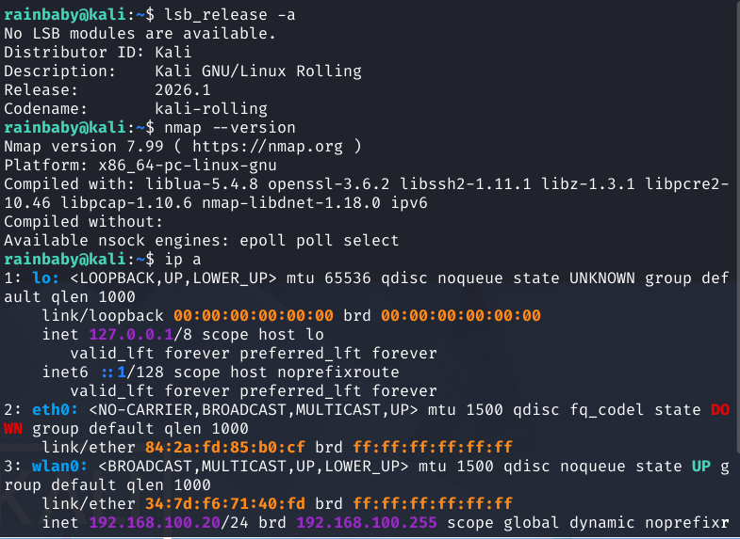

Step 1.2: Test Connection Between Kali and Metasploitable

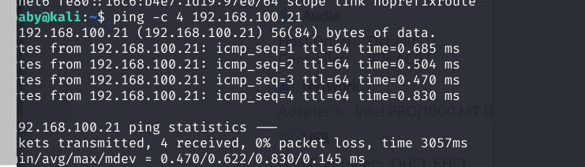
Connection successful between Kali and metasploitable

WEEK2: Penetration Testing

Step 2.1: First basic Scan
Category | Information
Target IP | 192.168.100.21
Attacker IP | 192.168.100.20
Host Status | Up (0.00042s latency)
Open Ports Found | 23 Ports

Scans the top 1000 ports on Metasploitable and lists all open ports
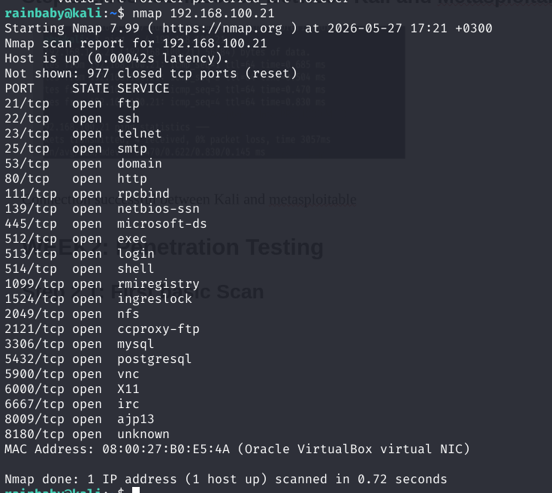

Scanning for vulnerabilities
Root account has empty password; anyone can access the MySQL database as root with no password.

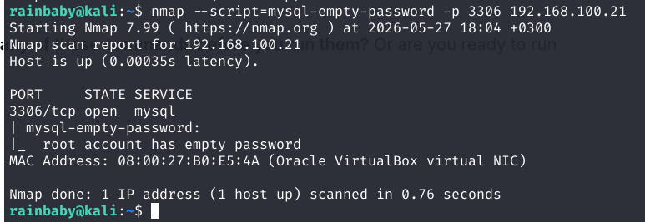

Port 1524-Known backdoor
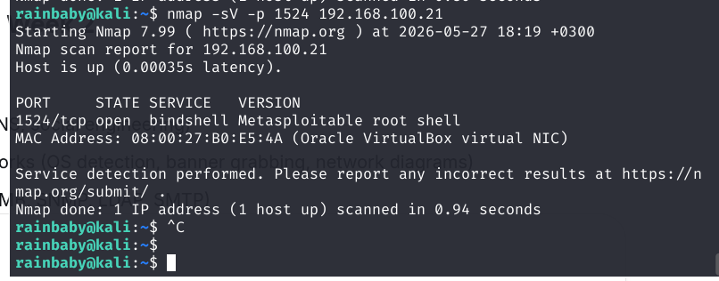
port 1524 is a backdoor anyone can connect and get immediate root access with no password (Bindshell-Metasploitable root shell)

WEEK 3: FOOTPRINTING

3.1 DNS FOOTPRINTING
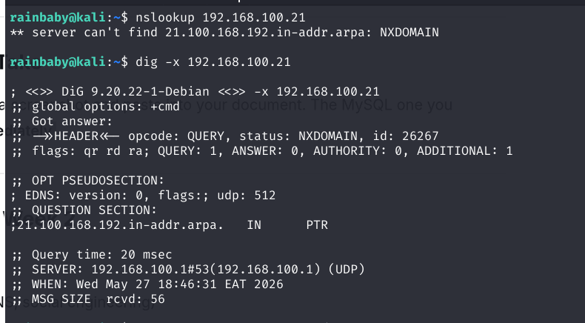
No reverse DNS record found for target IP 192.168.100.21.
Reverse DNS lookup returned NXDOMAIN. No PTR record configured, target has no hostname

3.2 SOCIAL ENGINEERING FOOTPRINTING

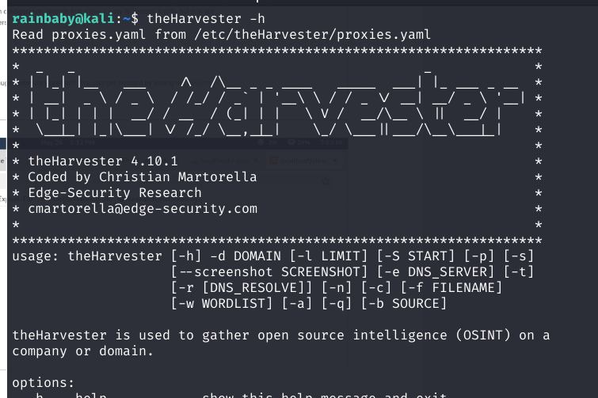

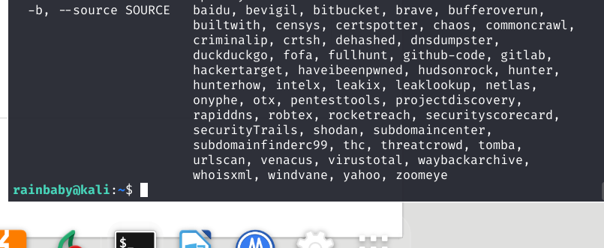

WEEK 4: Scanning networks

4.1 Network Scanning

Scanning for live hosts on my network
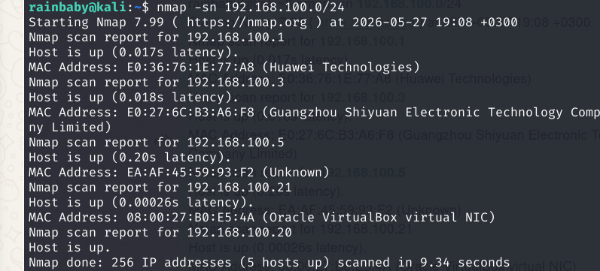
Discovered five live hosts including my target.

4.2 Port scanning
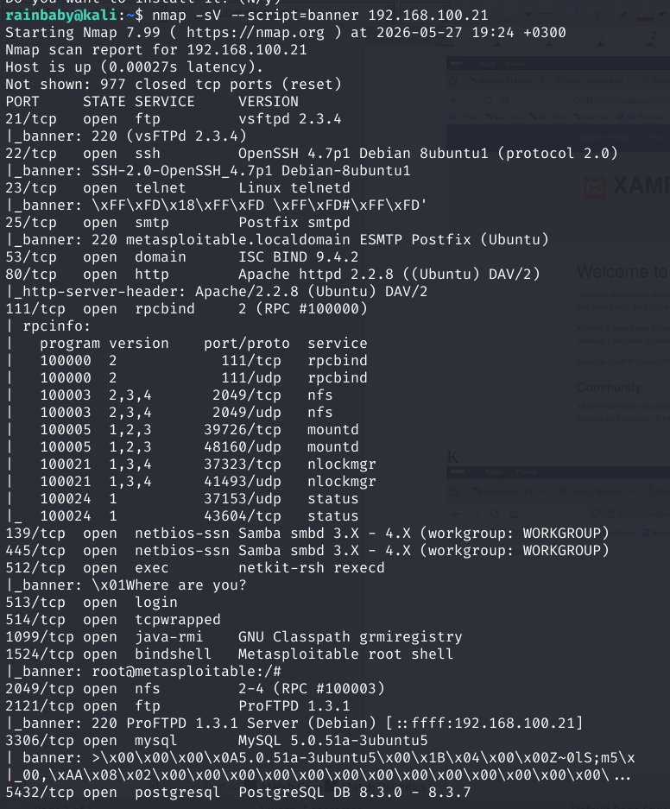
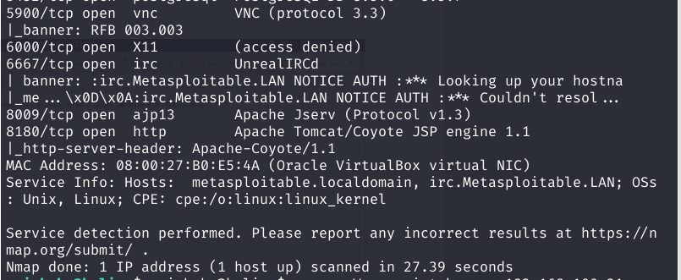
Performed port scan using Nmap with service version detection and banner grabbing. The scan revealed 23 open ports running outdated software versions including vsftpd 2.3.4 which has a known backdoor, Apache 2.2.8, and MySQL 5.0.51a.

WEEK 1-4 SUMMARY REPORT
I set up my lab with kali and metasploitable on the same network so they could talk to each other. I ran my first Nmap scan and found 23 open ports on the target. I did DNS foot printing using nslookup and dig. There were no reverse DNS records, which is normal for local networks. I also tried social engineering footprinting using theHarvester to practice finding emails. On week 4 I scanned the network and found five live devices then I did a detailed port scan with service detection and banner grabbing. I found outdated software like vsftpd 2.3.4 and a critical backdoor on port 1524 that gives root access with no password.

WEEK 5: INFORMATION GATHERING
Company identified: KPLC

5.1 Domain Registrar

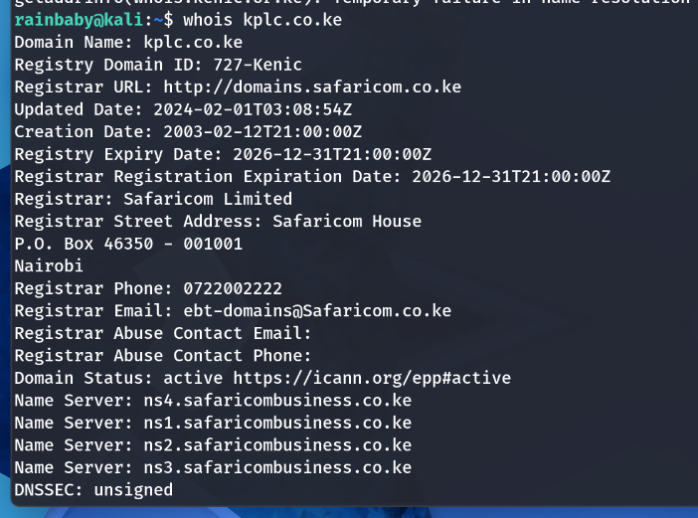

5.1.1 IP Address

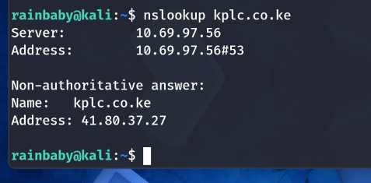

5.1.2 Email Patterns Used
The harvester and whatweb
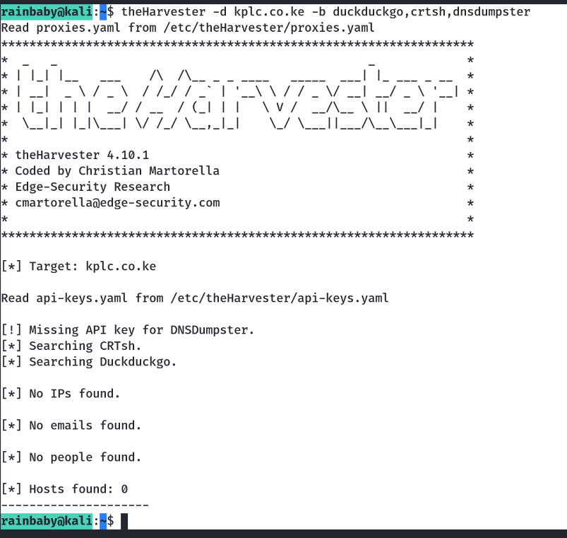
FirstInitialLastName@kplc.co.ke
OKagia@kplc.co.ke
customercare@kplc.co.ke

5.2 Technologies Running on the Website
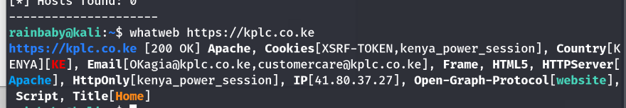
Apache, Html5, XSRF-TOKEN cookies, HTTPOnly

5.3 Scanning and Enumeration

5.3.1 Scanning Ports

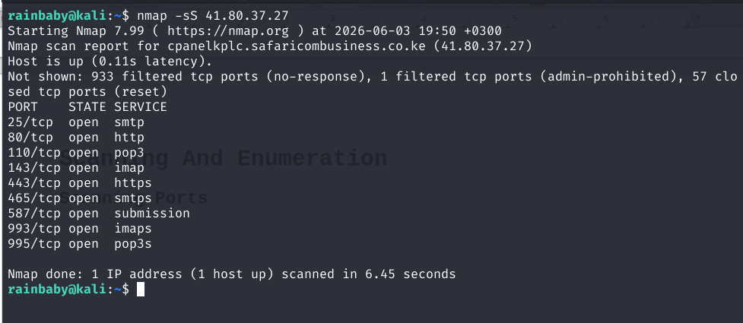
5.3.2 Detect Running Services

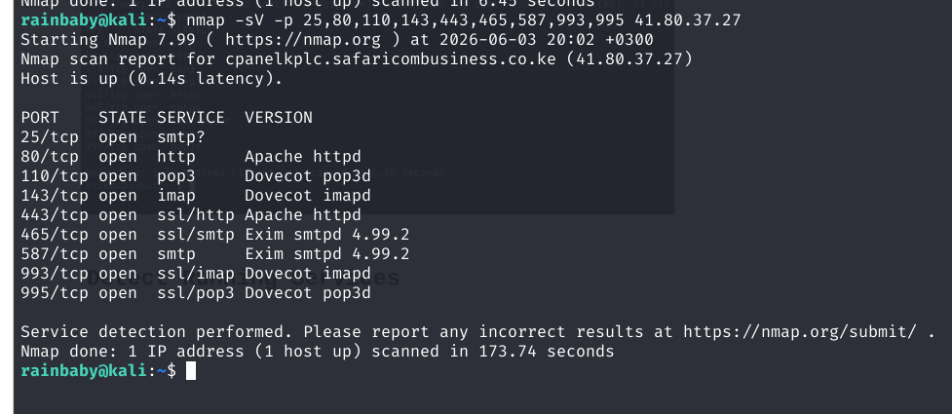
5.3.3 Identifying the OS Version
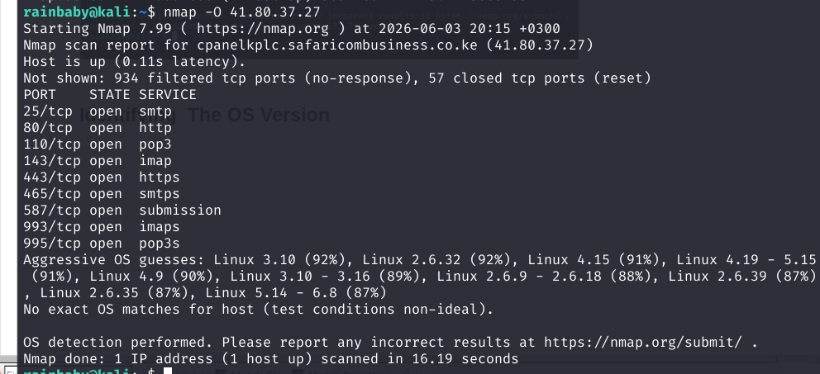

5.3.4 Enumerate Shared folders
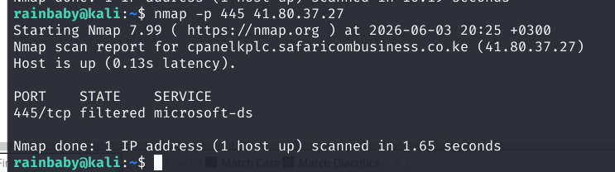
A firewall is actively blocking access to this port. No shared folders can be enumerated because the port is not accessible.
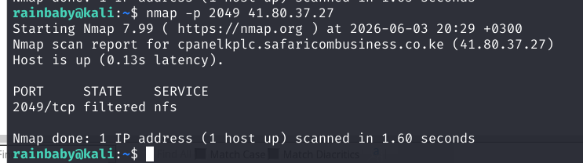

Student Reflection
I used whois to find that kplc.co.ke is registered by Safaricom Limited. Lookup gave the IP address 41.80.37.27. TheHarvester found no emails but whatweb revealed OKagia@kplc.co.ke and customercare@kplc.co.ke, showing email pattern is FirstInitialLastName. Whatweb also showed Apache web server. For scanning, I used Nmap on the IP. Port scan found 9 open ports including SMTP, HTTP, POP3, IMAP, and HTTPS. Service detection showed Exim 4.99.2, Dovecot, and Apache. OS detection suggested Linux kernel 3.10 which is very old. Shared folder ports 445 and 2049 were filtered which is good. The main risk is the outdated OS and Exim version with known vulnerabilities.

Second Company identified

Company Identified: uonbi.ac.ke

Domain Registrar

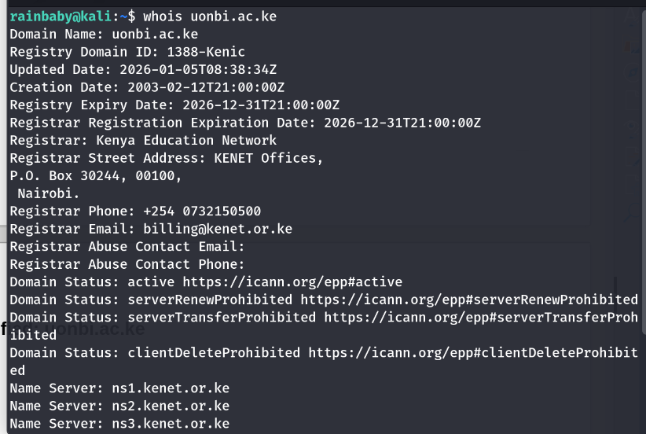
IP address
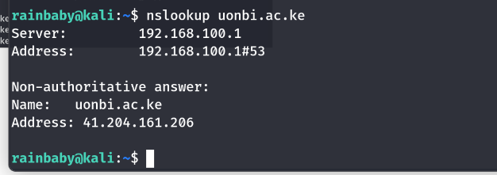
Email Patterns
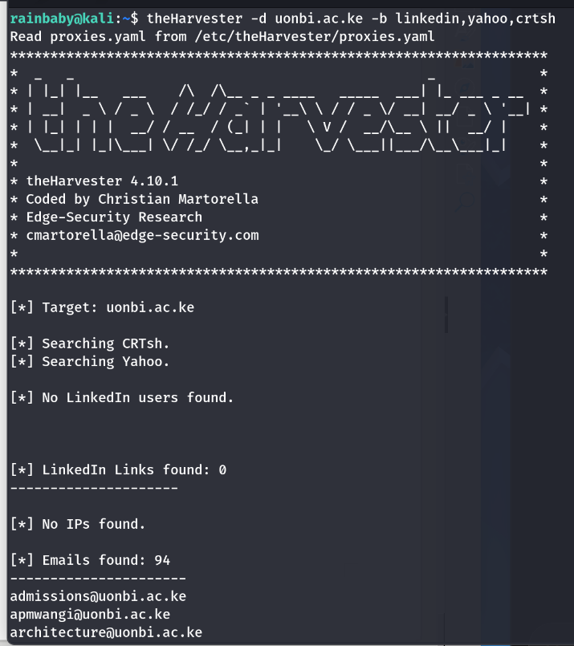

Pattern | Example | Explanation
Role-based | admissions@uonbi.ac.ke | Generic email for a department or role
Initials + Last name | apmwangi@uonbi.ac.ke | First and middle initials (apm) followed by last name (Mwangi)
Department-based | architecture@uonbi.ac.ke | Email named after faculty or department

Technologies Running On the website

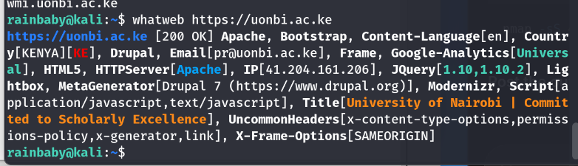

Scanning And Enumeration

Scanning ports
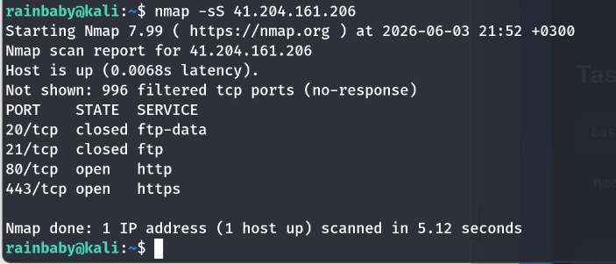

Detect Running Services
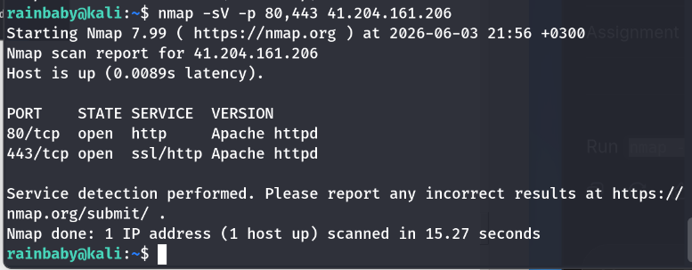

Identifying OS Version
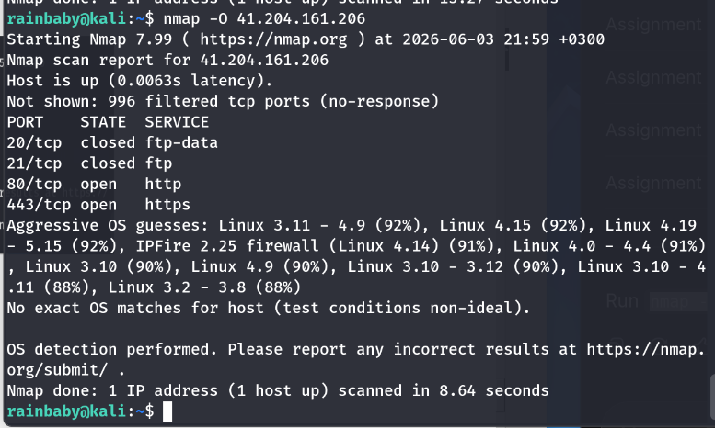

Enumerate Shared Folders
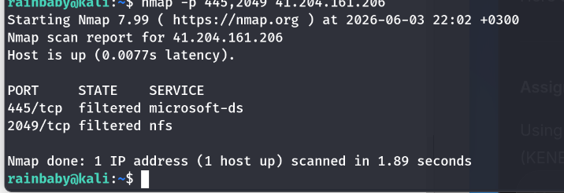

Student Reflection
Using whois, I found uonbi.ac.ke is registered by Kenya Education Network (KENET) with IP 41.204.161.206. TheHarvester revealed 94 emails including admissions@ and apmwangi@, showing patterns like role-based and firstinitial + lastname. Whatweb showed Apache, Drupal 7, and jQuery 1.10.2. Drupal 7 is End-of-Life which is a critical risk. For scanning with Nmap, only ports 80 and 443 were open running Apache httpd. OS detection suggested Linux kernel 3.11-4.9. Shared folder ports 445 and 2049 were filtered which is good. The main risks are outdated Drupal 7 and old Linux kernel with known vulnerabilities.

